SUPPLEMENTAL MATERIALS

Supplemental Material 1. Summary information for 836 collections of wild and hatchery Brook Trout. Column abbreviations are as follows: n - number of samples, N_{a} - mean number of alleles per locus, A_{R} - rarefied allelic richness, H_{O} - observed heterozygosity, uH_{e} - unbiased expected heterozygosity, F_{IS} - inbreeding coefficient, %P percentage of polymorphic loci, N_{e} - effective population size and 95% confidence interval, HW - percentage of loci with statistically significant deviations from Hardy-Weinberg expectations, and LD - percentage of loci pairs that show significant linkage disequilibrium.

[Provided as separate .xlsx file]
Supplemental Material 2. Bayesian Information Criterion (BIC) scores from DAPC models with a range of assumed clusters (K = 1 to K = 200).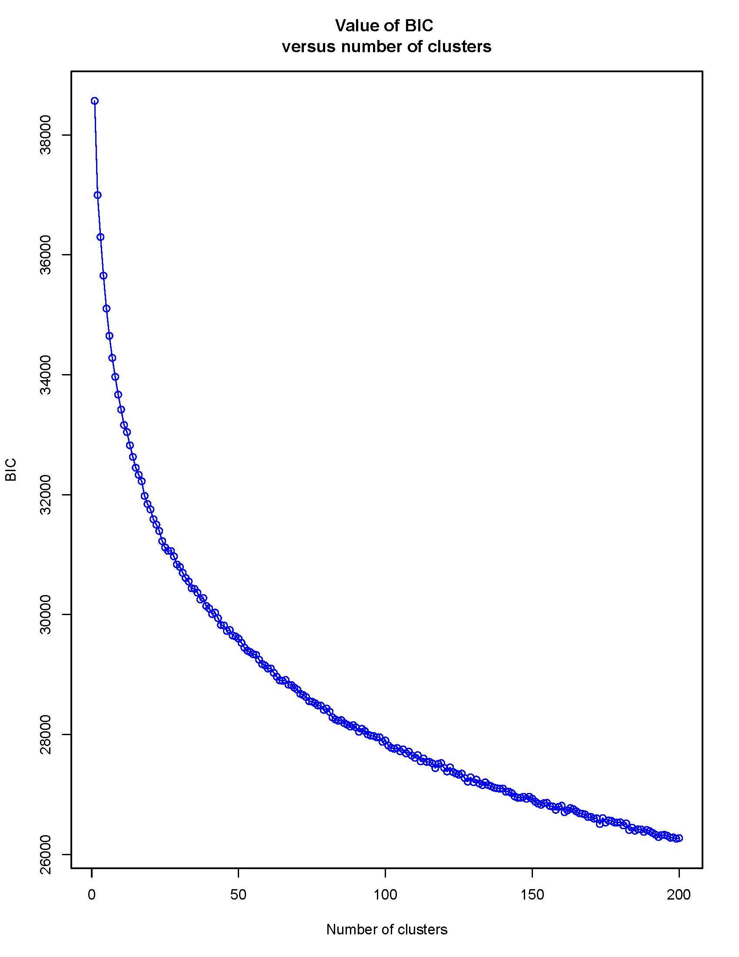

Supplemental Material 3. STRUCTURE Analyses

To further examine population structure, we applied an individual-based statistical approach implemented in STRUCTURE v. 2.3.4 (Pritchard et al. 2000) to infer clusters of genetically distinct populations and to assign individuals to clusters. We used the admixture ancestry model with correlated allele frequencies. The best-supported number of clusters (K) was assessed based on the highest value of Ln Pr(X|K) and the ΔK method of Evanno et al. (2005) with K = 1–25 and with 10 independent runs for each value of K. All runs consisted of a burn-in of 50,000 steps, followed by 100,000 Markov chain Monte Carlo iterations. We performed STRUCTURE analysis twice, the first time with the full dataset of 21,998 individuals from 836 collections. To address possible issues posed by uneven sample size (Puechmaille 2016), data from collections with fewer than 20 individuals were removed, and we repeated STRUCTURE analysis using data from 20,220 individuals from 665 collections. Since this analysis yielded higher LnP(X|K) values and lower variances, those results are reported here.

Bayesian analysis of multilocus genotypes for different presumed numbers of clusters K = 1–25 showed log likelihoods LnP(X|K) increasing with K but with variances tending to increase (Supplemental Table 3.1), a result typical of such analyses (Puechmaille 2016). Using the criterion of highest likelihood of the data given K, LnP(X|K) (Pritchard et al. 2000), successively higher K values were better supported. Using the ΔK criterion of Evanno et al. (2005), an approach that is best suited for inferring higher-order levels of differentiation, K = 2 was best supported. At K = 2 (Supplemental Figure 3.1A), one of the two clusters, shown in green, was distributed throughout much of the southern portion of the species’ range, and would presumably represent what has been traditionally referred to as southern Appalachian Brook Trout. Contributions from this cluster were distributed not only to the southwest of the New River drainage, but also farther north on the west side of the Eastern Continental Drainage Divide in West Virginia, with smaller contributions in Pennsylvania, southwestern New York, and Ohio. At K = 2, all the hatchery populations showed high levels of assignment to the northern lineage of Brook Trout. In contrast, the Brook Trout propagation facility at Tellico (Tennessee), which is dedicated to restoration of southern Appalachian Brook Trout using the progeny of wild fish, showed high assignment to the southern lineage. Further, likely biologically meaningful substructure was observed at higher values of K. At K = 3, populations in the Pigeon River watershed of North Carolina were clustered separately from other Brook Trout populations. At K = 4 (Supplemental Figure 3.1B), a northern cluster of populations (shown in magenta) was distinguished from a central Appalachian cluster (green) and a southern Appalachian cluster (blue). Several West Virginia and Blue Ridge Mountain, Virginia, populations clustered with the Pigeon River populations. At K = 6 (Supplemental Figure 3.1C), a new cluster of 21 populations in central Virginia was separated, most but not all on the east side of the Blue Ridge Mountains in the Rapidan and Rappahannock river basins. At K = 4, the hatchery stocks were predominated by northern lineages, with small, varying contributions from the mid-Appalachian lineage, with only the Big Hill Pond stock exhibiting a predominance of the mid-Appalachian lineage. At K = 5, the compositions of northern-lineage hatchery stocks varied little (Supplemental Figure 3.1D).

There was also a signature of apparent introgression of the northern Brook Trout lineage into some southern Brook Trout populations. At K = 10, northern Brook Trout comprised three apparently native clusters, plus the Virginia Blue Ridge cluster; southern populations comprised six clusters that tend to fall within HUC8 watersheds. At K = 20, some geographic structure in the north corresponded to HUC2 watershed and some to smaller units. For example, particular clusters occurred in the Acadian region of Maine, New Hampshire, eastern Vermont, and Massachusetts. Another cluster occurred in the Susquehanna watershed. An additional cluster was associated with coastal drainages in New Hampshire, Massachusetts, and coastal New York; this cluster also was well represented in nine hatchery strains, with representation presumably from these hatchery strains apparent in populations in other non-contiguous regions.

Another cluster corresponded to the Potomac drainage. In the south, the geographic distributions of clusters were more fine-grained, pertaining to HUC6 or smaller units. The HUC6 New River drainage had a cluster. North Carolina, Tennessee, and more southwesterly clusters tended to align with HUC8 watersheds. At K = 25, a Great Lakes cluster included populations in Wisconsin and the Adirondacks region of upstate New York. Other clusters were generally similar to those observed at K = 20. The southern part of the range was more finely divided, with many clusters aligning with HUC8 watersheds. With such fine distinctions among clusters, the effect of stocking hatchery fish was apparent in some populations. For example, the Wisconsin and upstate New York populations showed a signature of stocking hatchery fish derived from a coastal Acadian ancestry. Additional clustering results can be viewed using the interactive web-based viewer.

Supplemental Table 3.1. Results of STRUCTURE Bayesian cluster analysis of multilocus genotypes at 13 microsatellite loci in Brook Trout populations. LnP(D) = log probability of the data given K, where K = a set number of clusters. Results presented are the mean LnP(D) from five iterations. The full dataset included 21,998 individuals in 836 populations; the reduced dataset included 20,220 individuals in 665 populations. Each run was performed with a burn-in of 10,000 and 100,000 MCMC cycles.

 | Full dataset |  | Reduced dataset
K | LnP(D) | Var LnP(D) | LnP(D) | Var LnP(D)
1 | -1,141,514 | 150 | -1,052,110 | 148
2 | -1,041,843 | 8,265 | -960,897 | 8,348
3 | -1,007,755 | 16,356 | -936,369 | 13,466
4 | -980,683 | 23,667 | -906,857 | 19,240
5 | -958,829 | 27,167 | -877,017 | 21,983
6 | -933,937 | 24,222 | -860,700 | 22,225
7 | -917,655 | 27,527 | -841,769 | 24,065
8 | -902,905 | 27,978 | -836,905 | 25,350
9 | -890,953 | 29,664 | -817,599 | 26,658
10 | -880,322 | 30,659 | -807,473 | 29,130
11 | -874,246 | 32,763 | -803,657 | 29,568
12 | -864,092 | 34,572 | -799,420 | 30,984
13 | -858,242 | 35,278 | -786,457 | 30,998
14 | -852,374 | 39,001 | -778,585 | 34,507
15 | -843,775 | 37,393 | -776,709 | 38,569
16 | -845,714 | 48,906 | -771,922 | 37,840
17 | -833,837 | 40,234 | -765,511 | 39,439
18 | -836,303 | 58,800 | -762,489 | 38,676
19 | -825,005 | 46,602 | -755,359 | 42,792
20 | -831,585 | 51,195 | -755,712 | 40,103
21 | -813,331 | 45,630 | -746,186 | 39,653
22 | -810,313 | 46,166 | -741,761 | 41,735
23 | -808,525 | 49,764 | -737,752 | 44,276
24 | -803,436 | 49,126 | -739,916 | 42,663
25 | -803,120 | 50,513 | -735,824 | 45,660

Supplemental Figure 3.1. Geographic distribution of STRUCTURE-based Bayesian population-level assignment to K = 2, 3, 4, or 5 clusters of multilocus genotypes (panels A through D, respectively). The continental divide is shown with a heavy gray line. To observe population assignment results at finer scale or for populations farther north or west, visit http://ecosheds.org:3411/bkt/ and using the pull-down menu, select the STRUCTURE data layers. Samples outside of the eastern United States were truncated for visual purposes but were included in the analysis and can be viewed with the online viewer.

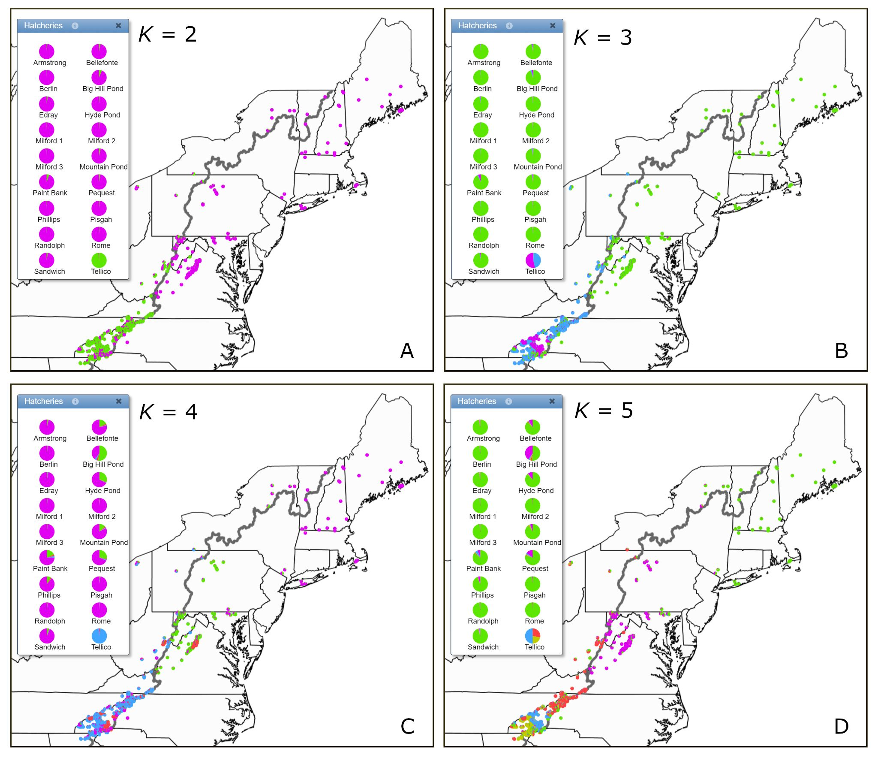

Supplemental Material 4. Collection-specific DAPC scores for K = 2 through K = 25.

[Provided as separate .xlsx file]
Supplemental Material 5. Case study - Limited introgression of hatchery fish into native populations of Brook Trout in Great Smoky Mountains National Park.

Great Smoky Mountains National Park (GRSM) provides a case study that exemplifies the relevance of our findings for management and integrates lines of evidence from previous work. Managers stocked Brook Trout raised in Park hatcheries throughout Park streams from 1936 (King 1939) through 1975 (Kulp and Moore 2005). During the 1930s, roughly 150,000 Brook Trout were stocked annually into 320 km of GRSM streams generally above 1,875 m at a rate of 300–600 Brook Trout per km (King 1939). Fingerlings came from York Ponds (NH), Berlin National Fish Hatchery (NFH) (NH), Walhalla NFH (SC), Erwin NFH (TN), Pisgah NFH (NC) or Kephart Hatchery in GRSM. Historical stocking records indicate that most Brook Trout broodstock originated from the Berlin strain; however, Brook Trout from local GRSM source streams, as well as the hatchery stocks mentioned above often were used as broodfish (D.C. Booth National Fish Hatchery, SD and GRSM archives).

Within GRSM, archival hatchery records indicate that between 1936–1974 approximately 166,853 hatchery-reared Brook Trout were stocked into 15 of the 53 (28%) streams sampled in this study. Microsatellite analysis indicates the presence of hatchery alleles in two of the 15 streams (13.3%) at all levels of K in STRUCTURE and K ≥ 7 in DAPC (Walker Camp Prong, 14,657 fish stocked; and Indian Flats Prong, 840). Hatchery alleles represented <50% of alleles in both streams. At K ≥ 7 in STRUCTURE, our results indicate the presence of hatchery alleles in three additional streams (five of 15; 33.3%). The numbers of fish stocked in those three additional streams were as follows: Road Prong, 23,873; Kephart Prong, a tributary to Walker Camp Prong, 14,657; and Huggins Creek, 12,349. Hatchery alleles represent <17% of alleles in each stream. Despite extensive hatchery stocking (range: 840–23,310 stocked) in the remaining 10 streams, there was no evidence of hatchery introgression at any level of K for STRUCTURE or DAPC.

The levels of introgression of hatchery-derived background observed in Walker Camp Prong, Road Prong, Kephart Prong, and Indian Flats Prong populations are not unexpected. Walker Prong, Kephart Prong, and Road Prong are all headwater tributaries to the West Prong Little Pigeon River. Besides the 14,657 Brook Trout stocked into Walker Camp Prong over seven years between 1936–1974, an additional 56,328 Brook Trout were stocked into West Prong Little Pigeon River over 17 years during this same period. Also, the U.S. Fish and Wildlife Service and National Park Service produced Brook Trout at a hatchery on West Prong Little Pigeon River just downstream of the confluence with Road Prong from roughly 1940–1965. Hatchery escape most likely added more Brook Trout to the system during these years. The Indian Flats Prong (Middle Prong Little River) watershed was being logged when the park was established in 1934. The heavy timber cut likely reduced Brook Trout abundance; therefore, 840 Brook Trout were stocked in the stream in 1936. The presence of hatchery and local alleles may indicate that hatchery fish were stocked onto an existing native population or native Brook Trout were mixed within the hatchery broodstock. Of the remaining 38 GRSM streams with molecular genetic data, there appeared to be no significant hatchery Brook Trout introgression within wild GRSM Brook Trout populations. Previous studies (Danzmann and Ihssen 1995; Jones et al. 1996; Burnham-Curtis 2001; Kazyak et al. 2018; Beer et al. 2019; Lehnert et al. 2020) also have indicated limited levels of hatchery Brook Trout introgression with wild populations despite extensive stocking histories.

Supplemental References

Beer, S. D., S. Cornett, P. Austerman, B. Trometer, T. Hoffman, and M. L. Bartron. 2019. Genetic diversity, admixture, and hatchery influence in Brook Trout (Salvelinus fontinalis) throughout western New York state. Ecology and Evolution 9:7455–7479.

Burnham‐Curtis, M. 2001. Genetic profiles of selected Brook Trout Salvelinus fontinalis populations from Lake Superior, Lake Huron and selected hatcheries. U.S. Fish and Wildlife Service, Ashland Fisheries Resource Office, Ashland, Wisconsin, and Great Lakes Science Center, Ann Arbor, Michigan.

Danzmann, R. G., and P. E. Ihssen. 1995. A phylogeographic survey of Brook Charr (Salvelinus fontinalis) in Algonquin Park, Ontario based upon mitochondrial DNA variation. Molecular Ecology 4:681–697.

Evanno, G., S. Regnaut, and J. Goudet. 2005. Detecting the number of clusters of individuals using the software STRUCTURE: a simulation study. Molecular Ecology 14:2611–2620.

Jones, M. W., D. Clay, and R. G. Danzmann. 1996. Conservation genetics of Brook Trout (Salvelinus fontinalis): population structuring in Fundy National Park, New Brunswick, and eastern Canada. Canadian Journal of Fisheries and Aquatic Sciences 53:2776–2791.

Kazyak, D. C., J. Rash, B. A. Lubinski, and T. L. King. 2018. Assessing the impact of stocking northern origin hatchery Brook Trout on the genetics of wild populations in North Carolina. Conservation Genetics 19:207–219.

King, W. 1939. A program for the management of fish resources in Great Smoky Mountains National Park. Transactions of the American Fisheries Society 68:86–95.

Kulp, M. A., and S. E. Moore. 2005. A case history in fishing regulations in Great Smoky Mountains National Park: 1934–2004. North American Journal of Fisheries Management 25:510–524.

Lehnert, S. J., S. M. Baillie, J. MacMillan, I. G. Paterson, C. F. Buhariwalla, I. R. Bradbury, and P. Bentzen. 2020. Multiple decades of stocking has resulted in limited hatchery introgression in wild Brook Trout (Salvelinus fontinalis) populations of Nova Scotia. Evolutionary Applications 13:1069–1089

Pritchard, J. K., M. Stephens, and P. Donnelly. 2000. Inference of population structure using multilocus genotype data. Genetics 155:945–959.

Puechmaille, S. J. 2016. The program STRUCTURE does not reliably recover the correct population structure when sampling is uneven: subsampling and new estimators alleviate the problem. Molecular Ecology Resources 16:608–627.

